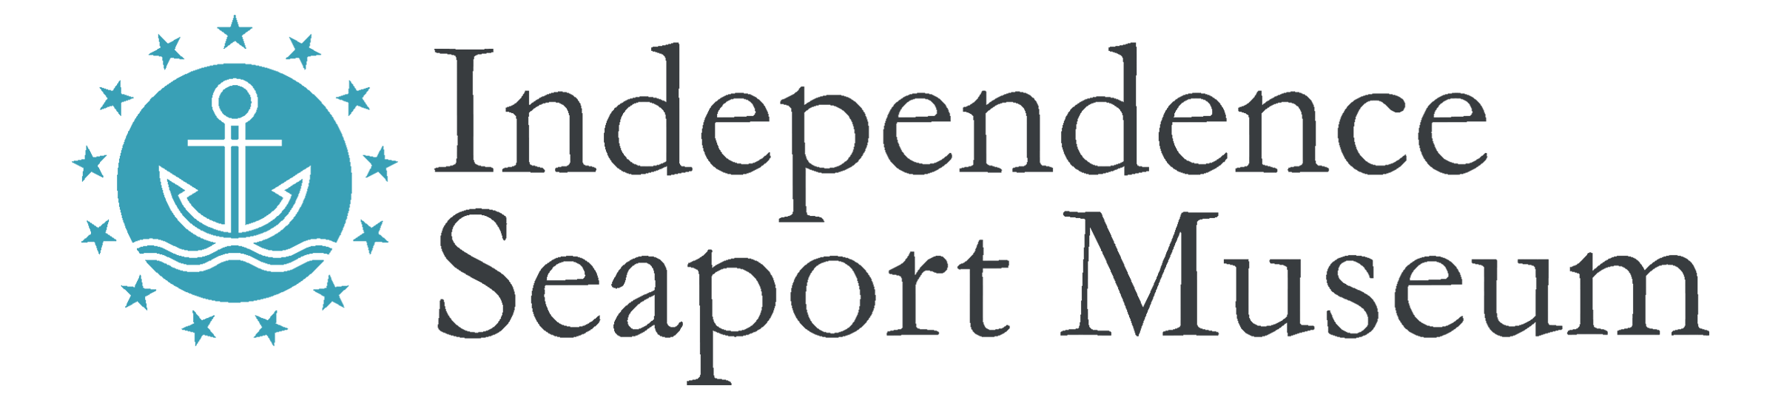

Title: Kayak Excursion Guide

Hours: Seasonal, runs from late April through early October. Most excursions are scheduled for weekends. Must be available for evening and holiday work. Most Kayak Excursion Guides work 4-10 hours per week during the summer season.

Compensation: Non-Exempt position; Starting at $14/hour

Reports to: Assistant Director of Waterfront and Community Programs

Description: Excursion Guides provide kayaking instruction and lead kayaking trips from the Independence Seaport Museum to historic and environmental landmarks along the Delaware River and connecting waterways. Excursion Guides manage groups of 10-15 people during dockside and on- water programming, including outfitting, instruction, safety expectations, boarding, paddling and debriefing. This position can be combined with a position as a Dock Hand for additional hours.

Qualifications:
- Previous kayaking experience required
- Teaching, mentoring or guide experience required
- Experience in incident-response or incident- management required
- Experience working with the public required
- First aid certification required (training provided)
- PA Boating Safety Education Certification, Lifeguarding Certification, Swift Water Rescue and/or Kayak Instruction Certification a plus
- Comfortability handing on-water emergency situations
- Ability to represent the Museum to potential visitors
- Strong verbal and written communication skills needed
- Strong group management skills necessary
- Basic computer skills
- Ability to stand and sit for long hours outdoors in the summer weather and ability to lift 50 lbs.
- PA Child Abuse History Clearance required (Museum paid)
- Must be over the age of 18

Essential Duties:
- Lead kayak tours on the tidal Delaware River
- Manage groups of 10-15 participants
- Observe and enforce proper safety standards during excursions
- Properly fit customers with Personal Floatation Devices
- Teach customers to safely and how to efficiently operate their vessels
- Safely assist customers into and out of boats
- Calmly respond to and document any near misses or incidents that occur during waterfront programming, according to training
- Prepare boats for usage and end-of-day storage: pumped out, cleaned, and tied off properly
- Communicate regularly with Assistant Director of Waterfront and Community Programs about weather and/or safety related concerns
- Actively use scheduling software, in accordance with training
- Model the Dock Staff Expectations
- Follow all Waterfront policies, practices and procedures
- Assist with all dockside related programming and events

Independence Seaport Museum is an equal opportunity employer committed to diversity in its visitors, board, and staff. The Museum does not discriminate on the basis of race, color, sex, sexual orientation, gender identity, religion, creed, national or ethnic origin, age, disability, veteran status or any other legally protected class status. People demonstrating a commitment to diversity and multiculturalism are encouraged to apply.

Independence Seaport Museum deepens the appreciation, understanding and experience of the Philadelphia region’s waterways through history, science, art and community. For more information, please visit phillyseaport.org.

