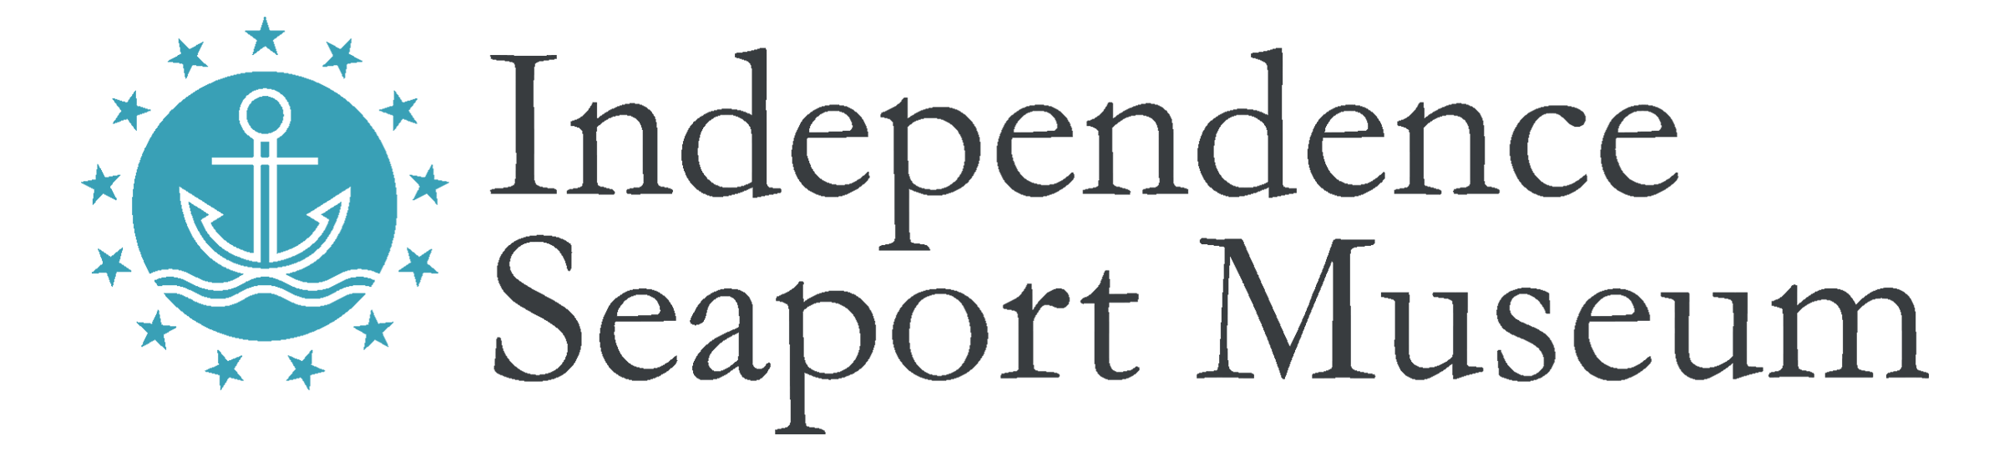

Title: Dock Hand at Paddle Penn’s Landing

Hours: Seasonal, May through September, Part time. Shift times include: weekend mornings/afternoons and afternoon/evenings from May – September and weekday mornings/afternoons and weekday afternoon/evenings from Memorial Day- Labor Day. At least 4 weekend days per month and at least one Summer Holiday required.

Compensation: Non-Exempt; Starting at $12/hr.

Reports To: Assistant Director of Waterfront and Community Programs

Description: Dock Hands are responsible for engaging the public in on-water programming on the Independence Seaport’s Waterfront. This includes teaching basic boating safety and skills to the public during Paddle Penn’s Landing, small boat rentals, special events such as water clean-ups, environmental educational opportunities, and for children and teens in many different summer camp groups. Required on-water training occurs late-April.

Qualifications:
- Previous experience in/on and around the water required
- Previous experience interacting with the public required with a strong and positive customer service orientation needed
- Previous teaching, supervising or mentoring experience preferred
- Experience with rowing, paddling, or other on-water activities preferred
- First aid certified required (training provided)
- Small boat, lifeguard, CPR certifications a plus
- Must be patient and able to remain calm in stressful situations
- Strong verbal and written communication skills
- Ability to represent the Museum to potential visitors
- Ability to stand for long hours outdoors in the summer weather and ability to lift 50 lbs.
- PA Child Abuse History Clearance required (cost paid by Museum)
- Must be 16 or older

Essential Duties:
- Model Dock Staff Expectations during each shift
- Follow all Waterfront policies, practices and procedures in accordance with training
- Properly fit customers with Personal Floatation Devices
- Safely assist customers into and out of boats
- Teach customers to safely operate their vessels
- Calmly handle situations on the water
- Prepare boats for usage and end-of-day storage (duties include: pumping water out of boats, cleaning boats, and ensuring boats are tied off properly)
- Perform routine maintenance and repairs on docks, boats, and equipment
- Actively use and update scheduling software, in accordance with training
- Assist with dockside related programming and events
- Welcome visiting ships and other boats on the dock and the landing, and assist with their docking and other needs.

The Independence Seaport Museum is an Equal Opportunity Employer that values diversity, inclusion, and equity as matters of fairness and effectiveness. We are committed to hiring and retaining a staff that reflects the diversity of the communities we serve, fostering an inclusive working environment where staff of all backgrounds feel welcomed and engaged in our mission. All qualified applicants will receive consideration for employment without regard to race, color, religion, gender, gender identity or expression, sexual orientation, national origin, genetics, disability, age, or veteran status.

Independence Seaport Museum deepens the appreciation, understanding and experience of the Philadelphia region’s waterways through history, science, art and community. For more information, please visit www.phillyseaport.org.

We are located on Penn’s Landing at 211 S. Columbus Blvd., Philadelphia, PA 19106. The Museum is easily accessible by public transportation and nearby parking and is ADA accessible.

