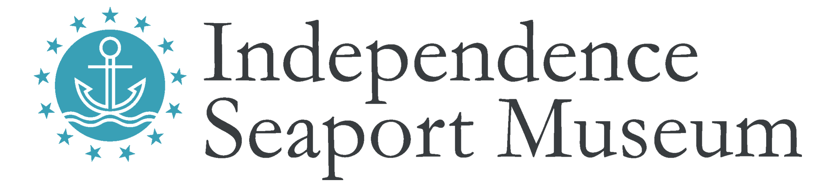

Title: Public Engagement Representative

Hours: Part-time, seasonal.

Reports to: Public Engagement Manager and Technology Support

Compensation: Non-exempt, $12/Hour

Description: Our Public Engagement Representatives are part of a dynamic team whose goal is to greet and interact with Museum guests. Individuals in this position are responsible for selling tickets to the museum, historic ships, and boat rentals, as well as occasionally assisting with public programming all while making customer service the highest priority.

Qualifications:
- Positive, friendly, welcoming attitude
- Good interpersonal communication and telephone skills
- Excellent organizational skills and attention to detail
- Excellent written and verbal communication skills
- Superior customer service skills
- Ability to work as part of a dynamic team, as well as independently on various projects
- Ability to handle confidential information
- Ability to work weekends, evening hours, or holidays as needed

Duties:
- Provide a positive, welcoming and helpful front of house experience
- Sell admission tickets at the front desk and various ticket booths
- Provide tourism information beyond the museum to visitors
- Assist in the selling and promotion of membership packages
- Service inbound calls and inquiries in a professional manner
- Maintain accurate cash drawers and reports
- Report out-of-order interactives or needed repairs in galleries to supervisor
- Receive deliveries and mail
- Act as host to birthday party groups and provide activities
- Occasionally assist in the operation of renting boats or bartending special events.

The Independence Seaport Museum is an Equal Opportunity Employer that values diversity, inclusion, and equity as matters of fairness and effectiveness. We are committed to hiring and retaining a staff that reflects the diversity of the communities we serve, fostering an inclusive working environment where staff of all backgrounds feel welcomed and engaged in our mission. All qualified applicants will receive consideration for employment without regard to race, color, religion, gender, gender identity or expression, sexual orientation, national origin, genetics, disability, age, or veteran status.

To apply:

Independence Seaport Museum deepens the appreciation, understanding and experience of the Philadelphia region’s waterways through history, science, art and community. For more information, please visit phillyseaport.org.

We are located on Penn’s Landing at 211 S. Columbus Blvd., Philadelphia, PA 19106. The Museum is easily accessible by public transportation and nearby parking, and is ADA accessible.

