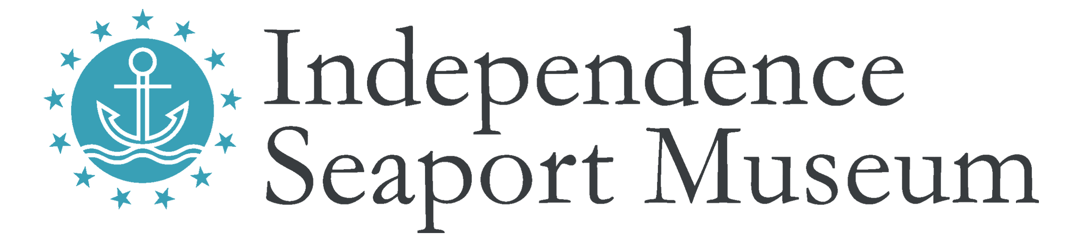

Title: Digital Content Manager

Hours: Full time, hours vary with events, overtime exempt. Occasional weekend and evening hours.

Compensation: Competitive; commensurate with experience

Reports to: Director of Marketing & Communications

Description: The Digital Content Manager creates digital content to support Independence Seaport Museum and its mission. They work on department strategy and the implementation, curation, and production including, but not limited to, social media, e-mail communications, websites, and videos.

Qualifications:
- Bachelor’s degree in communications, digital marketing, or a related field required.
- Minimum of 2-3 years of experience in website management, content strategy, and/or digital marketing.
- Experience with video editing and compilation preferred.
- Previous experience in a non-profit and/or museum preferred.
- Excellent writing, editing, and research skills, and ability to frame and draft compelling messages required.
- Proficient with basic HTML and CSS.
- Experience with Adobe Design Suite or similar design software preferred.
- Strong project-management and organizational skills.
- Friendly, organized, reliable, flexible, patient, enthusiastic team player.

Essential Duties:
- Assist in development of social media content, execute all social media efforts, and ensure integration of content across channels.
- Manage multi-channel digital campaign calendar, collaborating closely with colleagues across departments and overseeing the production and delivery schedule from each content creator.
- Edit video content to create uniformity of the ISM brand and improve the viewing experience for our followers.
- Curate all digital content provided to make sure it is in line with the Museum’s brand.
- Serve as website producer ensuring consistency of website content and strategy across digital properties.
- Manage the creation and distribution of a variety of e-newsletters and assist with database management.
- Develop digital cultivation strategies and ensure marketing tactics are implemented on time and within budget.
- Drive and increase social media following and engagement.
- Research and recommend features, functions, and solutions to create compelling digital content that enhances Independence Seaport Museum’s ability to reach and engage a broader constituency.
- Provide graphic design for social media content as needed.
- Manage internal production for updates to Independence Seaport Museum websites including planning, process, and policy development, monitoring, and metrics and reporting.
- Define and manage SEO/SEM strategies to increase search engine rankings.
- Maintain and utilize the Museum’s Google Ad Grant and analyze efficiently using Google Analytics.
- Manage metrics reporting and analysis of the website performance and online communications efforts.

The Independence Seaport Museum is an Equal Opportunity Employer that values diversity, inclusion, and equity as matters of fairness and effectiveness. We are committed to hiring and retaining a staff that reflects the diversity of the communities we serve, fostering an inclusive working environment where staff of all backgrounds feel welcomed and engaged in our mission. All qualified applicants will receive consideration for employment without regard to race, color, religion, gender, gender identity or expression, sexual orientation, national origin, genetics, disability, age, or veteran status.

To apply:

Apply to this position directly at https://phillyseaport.efficientapply.com/jobs/. No phone calls.

Independence Seaport Museum deepens the appreciation, understanding, and experience of our waterways through history, science, art, and community. For more information, please visit www.phillyseaport.org.

We are located on Penn’s Landing at 211 S. Columbus Blvd., Philadelphia, PA 19106. The Museum is easily accessible by public transportation and nearby parking and is ADA accessible.

