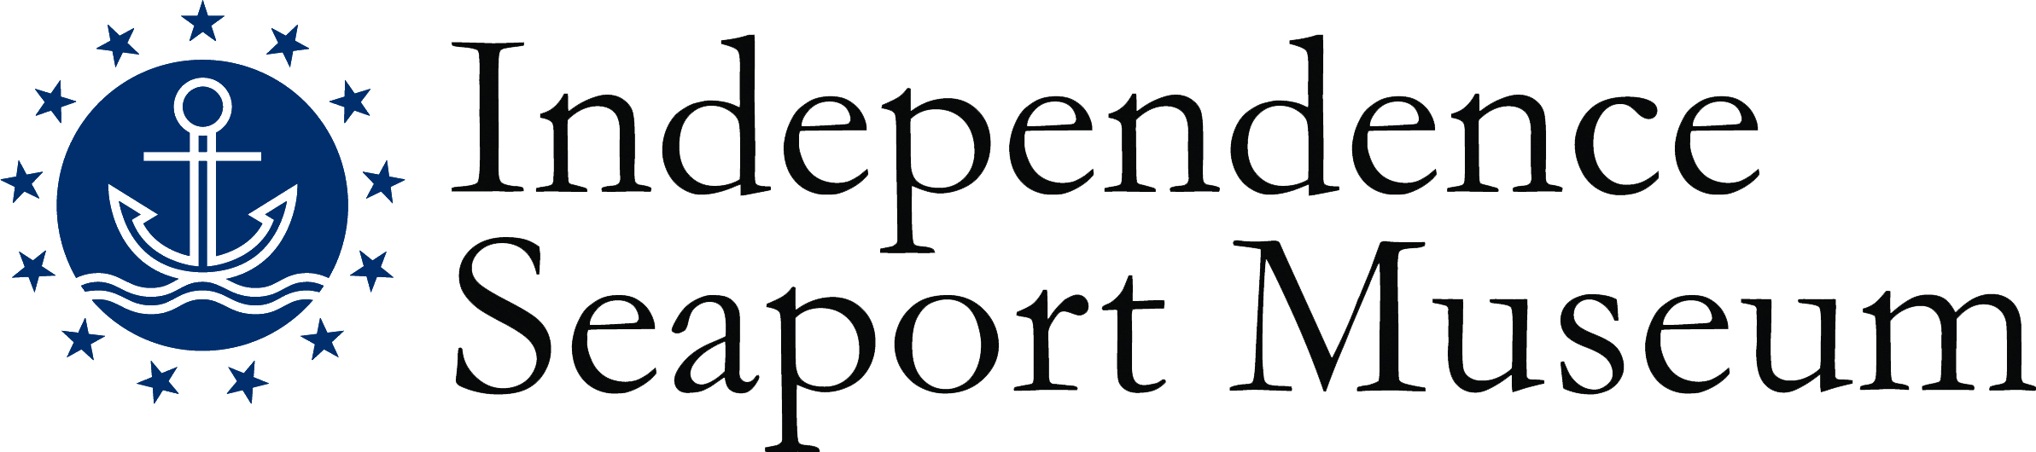
Title: Dock Supervisor

Hours: Seasonal, late April through early October. Shift times include: weekend mornings/afternoons and afternoon/evenings from May – September and weekday mornings/afternoons and weekday afternoon/evenings from Memorial Day- Labor Day. At least 4 weekend days per month and at least one Summer Holiday required.

Compensation: Non-Exempt, Part Time; Starting at $14/hour

Reports to: Assistant Director of Waterfront and Community Programs

Description: Dock Supervisors are responsible for ensuring that proper safety protocol and visitor assistance are provided during waterfront programming, including Paddle Penn’s Landing, small boat rentals, special events and summer camp. Dock Supervisors are responsible for monitoring and coaching Dock Hands and enforcing all Waterfront policies and procedures.

Qualifications:
- Previous experience in incident-response or incident- management required
- Previous experience with rowing, paddling, or other on-water activities required
- Previous experience working with the public required
- Previous teaching, supervising or mentoring experience preferred
- Previous experience working on boat docks preferred
- First aid certified required (training provided)
- Small boat certification and lifesaving certification a plus
- Strong communication skills, both verbal and written
- Basic computer skills
- Patience and the ability to remain calm in stressful situations
- Ability to stand for long hours outdoors in the summer weather and to lift 50 lbs.
- PA Child Abuse History Clearance required (Museum paid)

Essential Duties:
- Uphold and model the Dock Staff Expectations.
- Supervise Dock Hands during shifts.
- Follow and ensure compliance with all Waterfront policies, practices and procedures in accordance with training.
- Practice and oversee the practice of proper safety standards during waterfront programming.
- Safely assist customers into and out of boats
- Teach customers to safely operate their vessels
- Properly fit customers with Personal Floatation Devices
- Respond to and document any near misses or incidents that occur during waterfront programming, according to training.
- Communicate regularly with Assistant Director of Waterfront and Community Programs about weather and/or safety related concerns.
- Oversee and/or prepare boats for usage and end-of-day storage: pumped out, cleaned, and tied off properly.
- Oversee and/or perform routine maintenance on docks.
- Actively use scheduling software, in accordance with training.
- Assist with dockside related programming and events.
- Welcome visiting ships and other boats on the dock and the landing, and assist with their docking and other needs.

The Independence Seaport Museum is an Equal Opportunity Employer that values diversity, inclusion, and equity as matters of fairness and effectiveness. We are committed to hiring and retaining a staff that reflects the diversity of the communities we serve, fostering an inclusive working environment where staff of all backgrounds feel welcomed and engaged in our mission. All qualified applicants will receive consideration for employment without regard to race, color, religion, gender, gender identity or expression, sexual orientation, national origin, genetics, disability, age, or veteran status.

Independence Seaport Museum deepens the appreciation, understanding and experience of the Philadelphia region’s waterways through history, science, art and community. For more information, please visit phillyseaport.org.

We are located on Penn’s Landing at 211 S. Columbus Blvd., Philadelphia, PA 19106. The Museum is easily accessible by public transportation and nearby parking and is ADA accessible.

